Section II – Figures

Figure 1: 1.ii, Squares of Fourier Coefficients v. DFT Index

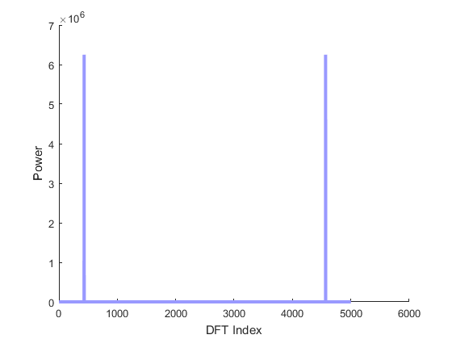

Figure 2: 1.iii, Squares of Fourier Coefficients v. Physical Frequency

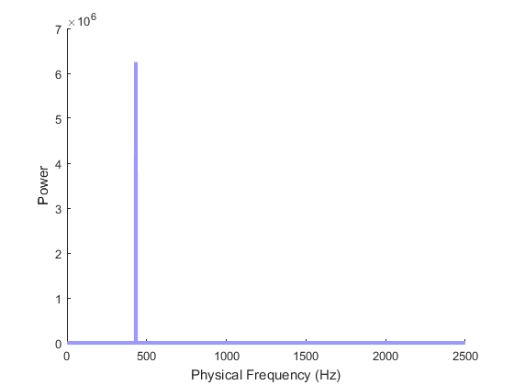

Figure 3: 1,iv Sum of Sinusoidal Signals Power

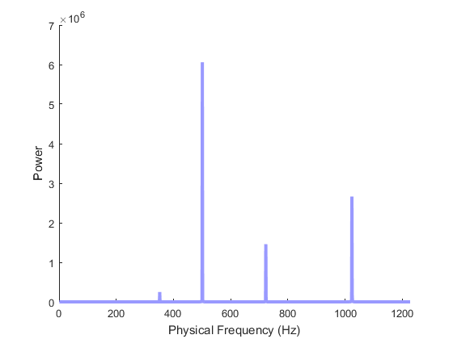

Figure 4: 1.v, Power Spectrum with Noise

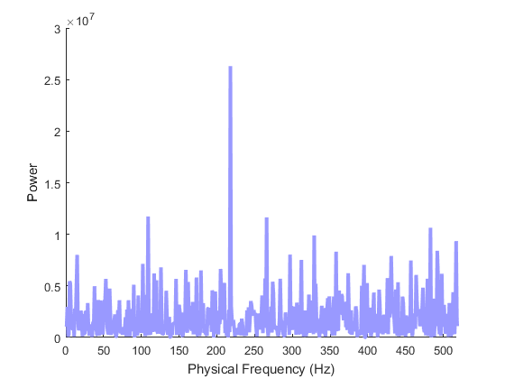

Figure 5: Noise Level 1, Time Domain

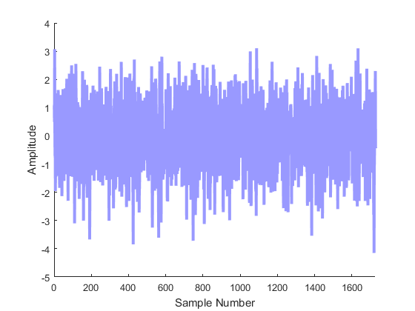

Figure 6: Noise Level 1, Power

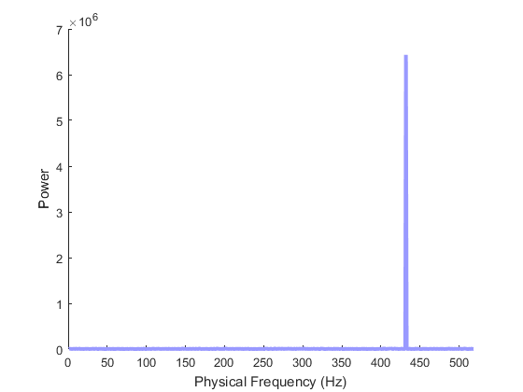

Figure 7: Noise Level 2, Time Domain

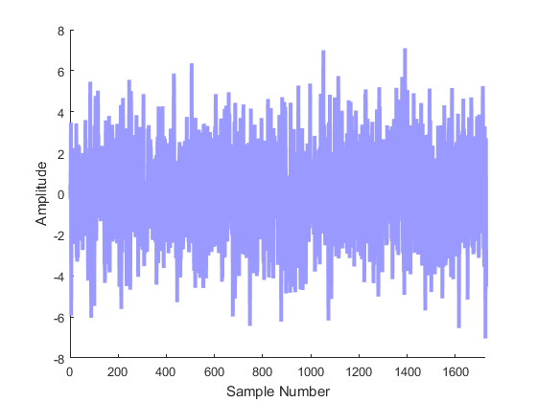

Figure 8: Noise Level 2, Power

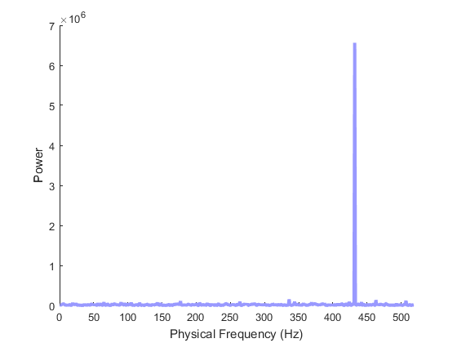

Figure 9: Noise Level 3, Time Domain

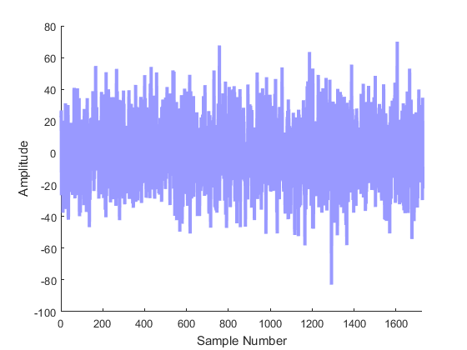

Figure 10: Noise Level 3, Power

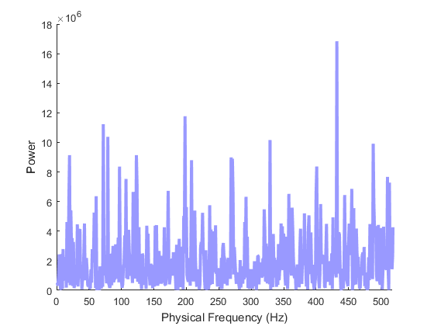

Figure 11: Power Spectrum of 'lab3prob2sound1.wav'

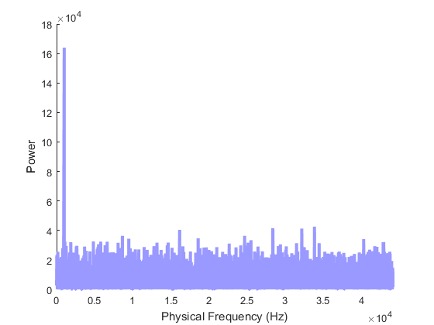

Figure 12: Power Spectrum of 'lab3prob2sound2.wav'

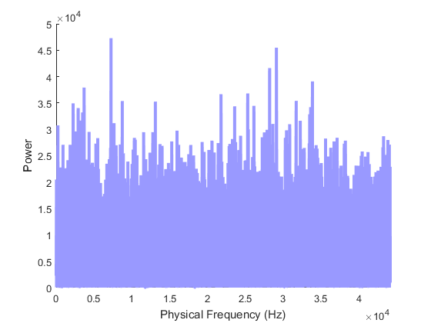

Figure 13: Power Spectrum of 'lab3prob2sound3.wav'

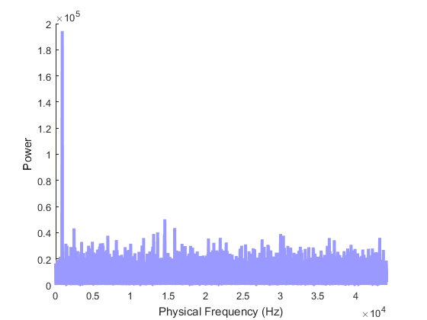

Figure 14: Power Spectrum of 'lab3prob2sound4.wav'

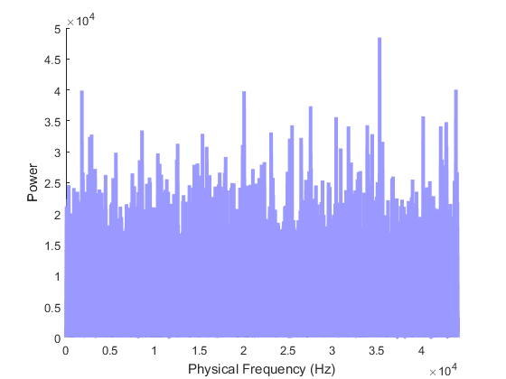

Figure 15: Power Spectrum of Filtered 'lab3prob2sound2.wav'

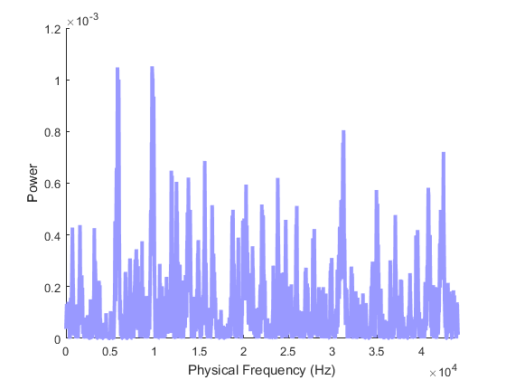

Figure 16: Power Spectrum of Filtered 'lab3prob2sound4.wav'

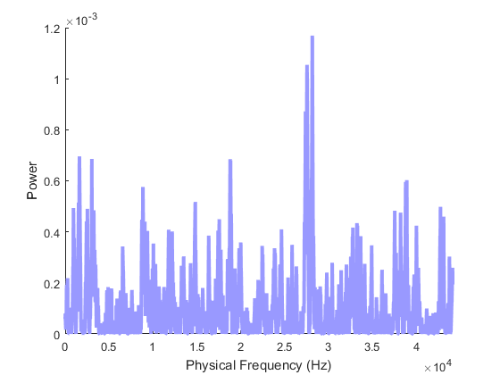

Figure 17: Power Spectrum of 'guitar-note.wav'

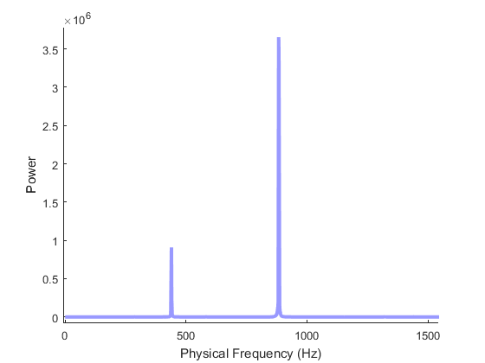

Figure 18: Lowpass Filter Response (Length 20)

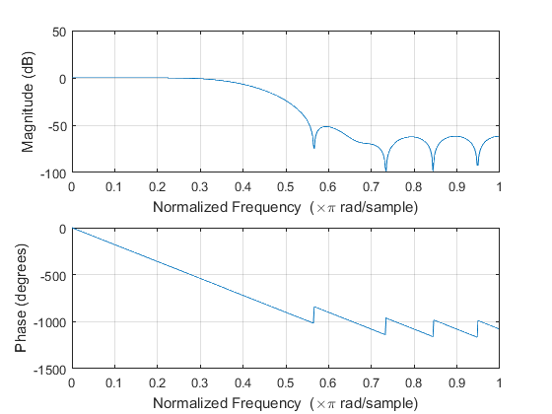

Figure 19: Lowpass Filter Response (Length 200)

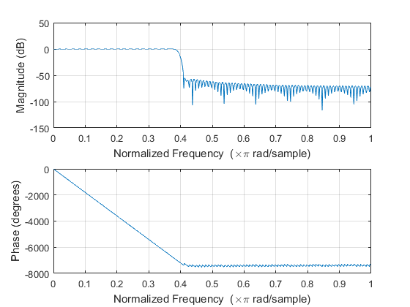

Figure 20: Highpass Filter Response (Length 20)

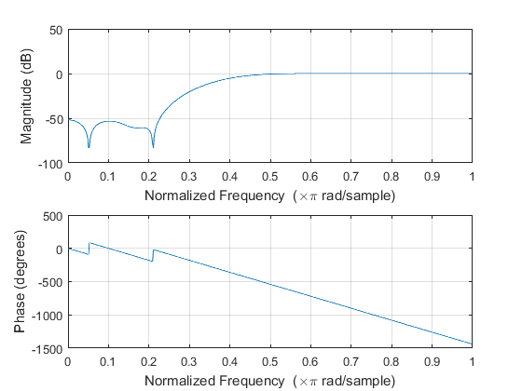

Figure 21: Highpass Filter Response (Length 200)

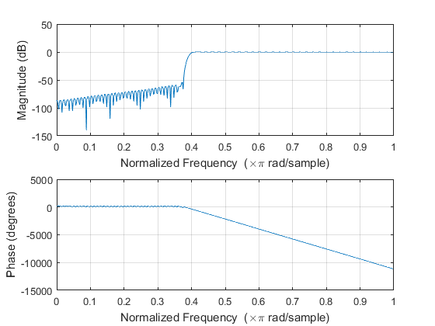

Figure 22: Bandpass Filter Response (Length 20)

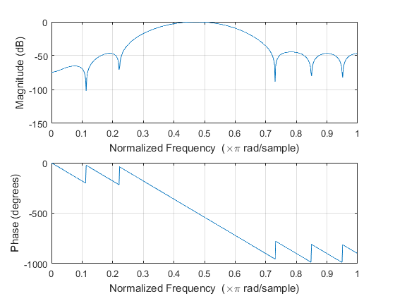

Figure 23: bandpass Filter Response (Length 200)

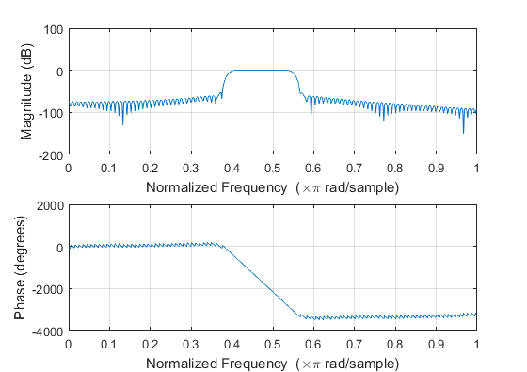

Figure 24: Power Spectrum of Generated Signal

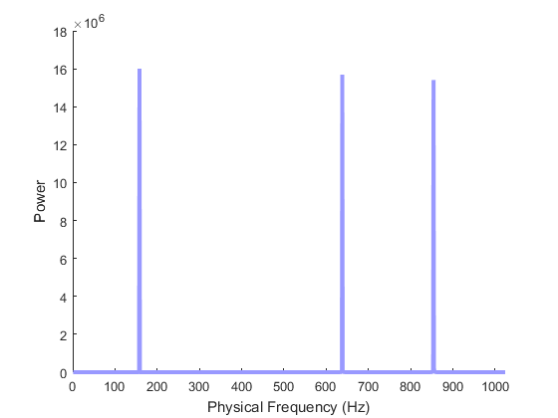

Figure 25: Power Spectrum of Lowpassed Signal

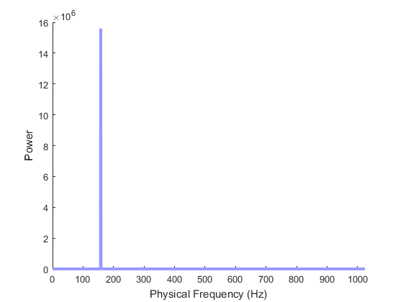

Figure 26: Power Spectrum of Highpassed Signal

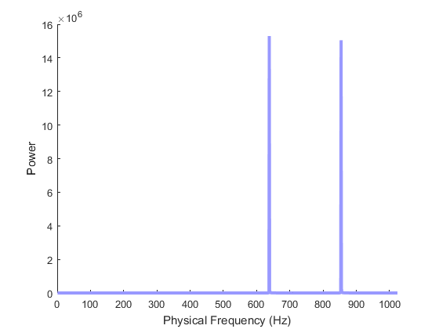

Figure 27: Power Spectrum of Bandpassed Signal

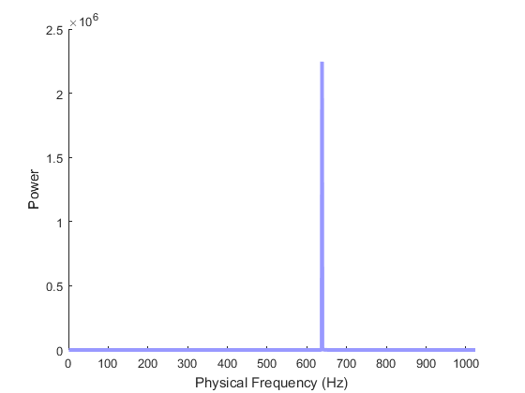

Figure 28: Power Spectrum of Gaussian Noise

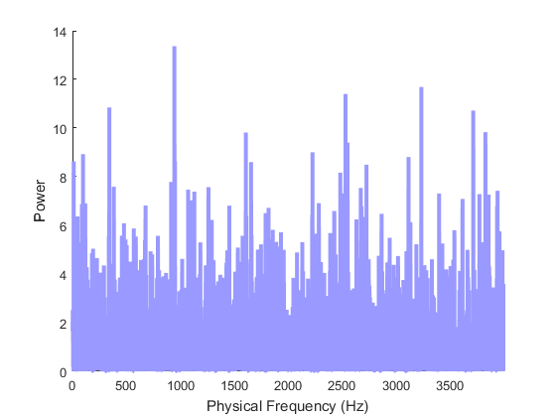

Figure 29: Power Spectrum of Bandpassed Noise

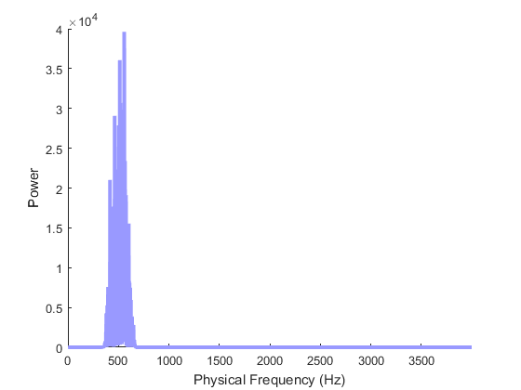

Figure30: Morse Code Power Spectrum

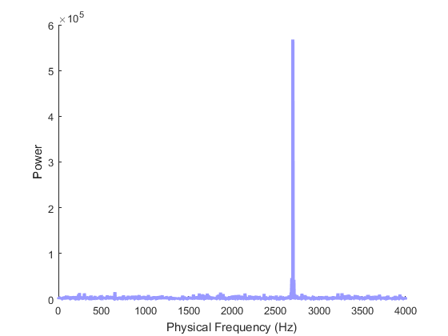

Figure 31: Spectrum of DTMF Signal

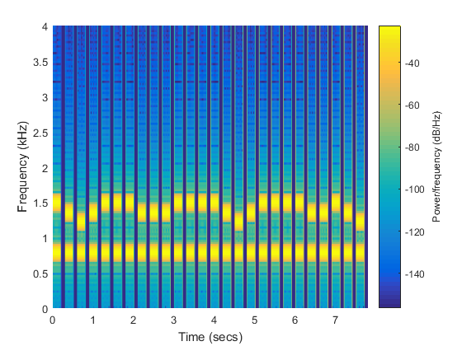

Figure 32: Power Spectrum for DTMF-1.wav

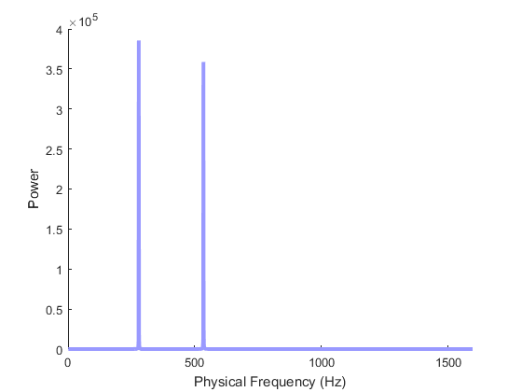

Figure 33: Power Spectrum for DTMF-2.wav

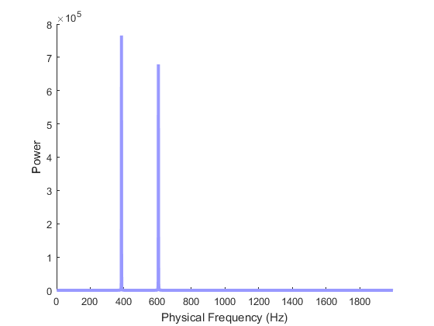

Figure 34: Power Spectrum for DTMF-3.wav

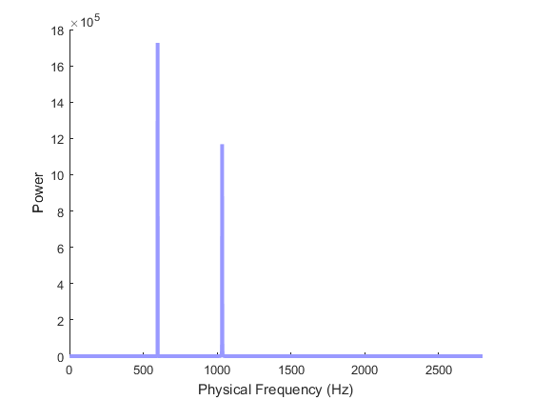

Figure 35: Power Spectrum for DTMF-4.wav

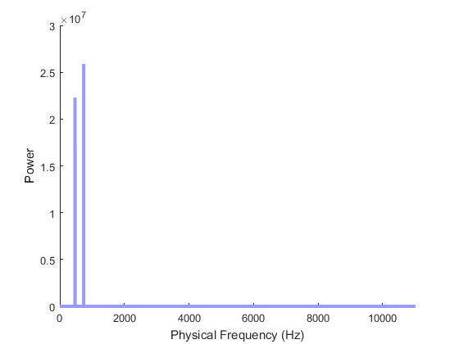

Figure 36: Power Spectrum for DTMF-5.wav

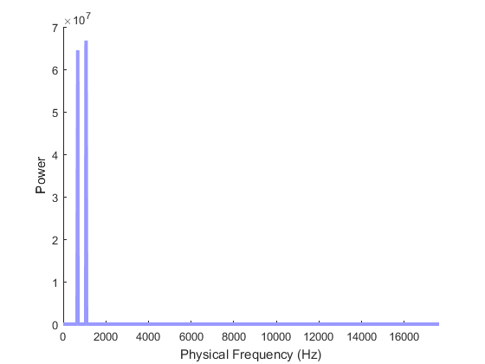

Figure 37: Power Spectrum for DTMF-6.wav

